Requirements
Compose the scene music for the online game , Heros of Kingdoms.
Requirements
format:44.1kHz, 16bit,stereo,wave file.
All music in length:10mins14s
Content: 3 scene musics,2 battle musics ,2 jingle(for the battle end)musics,1 state music,1 state jingle. A total of 9 musics.
Time limit:15 business days (3weeks)
Your works must be the final mix.
As the scene musics, its needs to reflect the overall genre as a whole.
Your must submit all audio track.
We hope you could mix the music immediately after we confirm it passed.
http://y3.163.com/download/This is the download website of Heros of Kingdoms, you could get more feelings with the game by following account: name: b7150477@163.com , code: 7058345

具体资源制作目录
Catalog for Specific Resources
编号  No. | 曲目  Track | 类型  Type | 优先级  Priority | 备注  Remarks | 参考曲目  Reference
1 | 探索音乐  Exploration Music | 场景音乐  Scene Music | 高  High | 最终输出时，需提供所有音乐的分轨素材和带混音的独立完整版本。  During the final output, track materials of all music and the complete independent remix version are required. | explore_001_layer01、layer02
2 | 战斗前  Pre-battle Music | 事件音乐  Event Music | 低  Low |  | prehorn
3 | 死亡音乐  Death Music | 状态音乐  Status Music | 中  Middle |  | death
4 | 复活  Resurrection Music | 状态音乐  Status Music | 中  Middle |  | respawn
5 | 战斗音乐  Battle Music | 战斗音乐  Battle Music | 高  High |  | battle_001、battle_002
6 | 战斗音乐结束句  End of Battle Music | 事件音乐  Event Music | 高  High |  | battle_001_end、battle_002_end
7 | 过道音乐  Passageway Music | 场景音乐  Scene Music | 中  Middle |  | laning_01_layer_02、layer02

英雄三国 5V5玩法介绍
Introduction of 5V5 of The Heroes of Three Kingdoms
战斗形式：
Battle Form:
5V5 的PVP ， 分3条路，每条路上会每隔30刷一波小兵， 击杀敌方的小兵可以获得金钱，经验，提升战斗力
For the PVP of 5V5, three routes, each with a group of batmen appearing every 30s, are provided. You can obtain money and experience point, and improve combat power by attacking the batmen from the enemy.
胜利条件：
Conditions for winning:
推到敌方的基地建筑： 绿色标记的 3号建筑
Push forwards to the base building of the enemy: No. 3 building with green marks.
地图内资源：
Resources on the map:
蓝色标记1-9 ： 防御塔， 外防御塔分为3层， 123 为最外层防御一塔，456 为 二塔， 789 为最靠近老家的防御三塔
Blue mark 1-9: defense towers, which are divided into three layers. 1, 2, 3 belong to Tier-one Tower, 4, 5, 6 Tier-two Tower, and 7, 8, 9 Tier-three Tower, which are the nearest to the base building.
红色标记1-6 ： 基地兵营 , 推到敌方的基地兵营，己方可以出动超级士兵来帮助你进行进攻
Red mark 1-6: base camp. To push forwards to the base camp of the enemy, you can use super soldier to help you launch an attack.
绿色标记1-3 ： 基地建筑， 1-2为基地防御塔 3为最后的基地建筑， 推到敌方的基地建筑即可获得比赛胜利
Green mark 1-3: base building. 1, 2 are base defense towers, and 3 is the last base building. After pushing to the base building of the enemy, you can win the game.
绿色标记1-3 ： 为地图上的boss点 1-4分别为 白虎，玄武，青龙，朱雀。 能力由弱到强，击杀奖励也由少到多
Green mark 1-3: boss points on the map. 1-4 are white tiger, black tortoise, green dragon, and rosefinch whose capacities and fighting rewards are in a rising scale.
比赛时长：
Game Duration:
1. 一般的比赛时长在30-40分钟内
The game duration is generally between 30 and 40 mins.
2. 实力相差悬殊的比赛，如果有一方投降的话，会在20分钟结束
Any game with a significant difference in strength, in case that any party surrenders, will be over in 20 mins.
3. 双方战术都比较保守的比赛会进行到40-60分钟
Any game with conservative tactics will last for 40-60 mins.
游戏进程（这里只说明一般情况下的游戏进程）：
Game Progress (hereafter only the game progress under general conditions will be described):
人头比分/ boss击杀/ 建筑情况 /团战情况
Character score/boss attack/building condition/team battle condition
DOTA类型的玩法，Dota以对立的两个小队展开对战，通常是5v5，正如该游戏名称所表现的，游戏目的是守护自己的基地，同时摧毁对方的基地。为了到达对方的基地，一方英雄必须战胜对方的部队、防御建筑和英雄。
玩家可以通过杀死对方小兵或者在战斗中杀死对方，获得金钱和经验来使自己的英雄升级，通过破坏对方防御塔也可以获取大量金钱。更多的经验能使英雄的技能增强或属性增加，而金钱则能在商店中购买更具威力的装备。
地图中分布着各色的中立怪物，英雄杀死野怪可获得金钱和经验，野怪等级不同，英雄所获得的金钱和经验也不一样。
DOTA-like game rules : in dota, two opposed teams combat against each other in the 5V5 mode. As shown by the game name, the objective of the game is to protect the base of your team while trying to destroy the enemy’s base. To reach the enemy’s base, your heroes must beat the enemy's troops, defense buildings and heroes.
All players can obtain money and experience point to update their heroes by killing the enemy or its batmen during the battle. They can get a large amount of money by destroying the enemy’s defense towers. The more the experience points are, the better the hero’s skill and attribute will be. And with money, players can buy more powerful equipments from the store.
On the map scatter various neutral monsters. Heroes can obtain money and experience points by killing the monsters. Killing monsters of different levels, heroes can obtain different amounts of money and experience points.
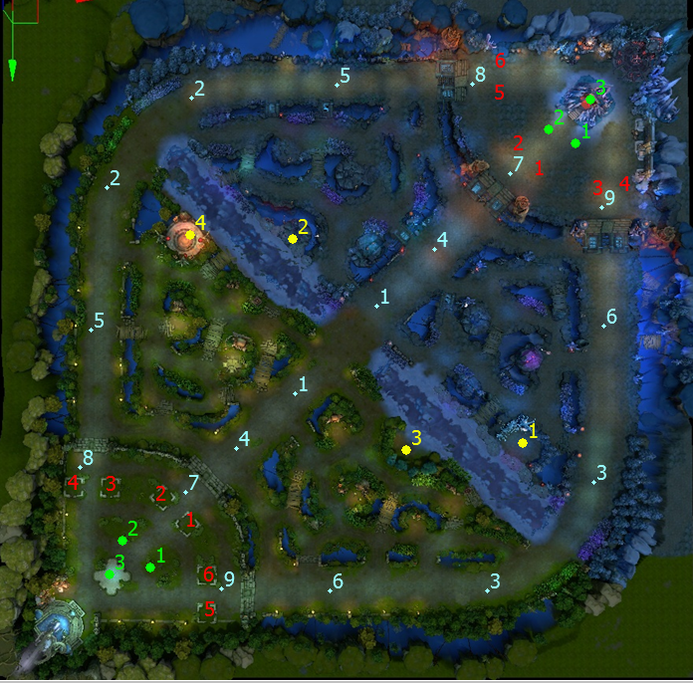
音乐名称  Music Name | 1.探索音乐（explore）  1.Exploration Music
音乐类型  Music Type | 场景音乐  Scene Music
触发方式  Trigger Manner | loop
最终提交时间  Final Submission Time | 2013/9/20
制作优先级  Production Priority | 高  High
音乐时长  Music Duration | 2min以内  Within 2 mins
画面/背景描述  Picture/Background Description | 5V5玩法的大场景，魏蜀争霸。  Large-scale 5V5 scene, war affairs between the kingdoms Wei and Shu
相关美术资源  Related Art Resources | （见下图）  (As shown in the figure below)
音乐风格综述  Summary of Music Style | 探索类型、神秘、不安、战斗前，由于场景充斥着战争迷雾遮掩着玩家的视野，所以玩家在游戏中一直处在一个探索的环境。虽然是氛围音乐但是还是希望有一定的旋律性，整体可以定义为史诗味很浓的氛围音乐。  It is mysterious, uneasy and pre-battle, recalling of exploration. As the misty war scene may cast a veil over the players' horizon, the players are always within an explorative environment. Although the music falls in the category of ambient music, the ambient melody is strong in an epic flavor.
音乐风格详述  Description of Music Style | 可以使用合成器音色，以管弦为主、民乐可稍做点缀。建议使用人声合唱来做铺垫。  A synthesizer tone can be adopted, accompanied by some orchestra and folk music. Choir can serve as a background.
音乐风格详述  Description of Music Style | 虽然是氛围音乐但是希望整体线条不要太过于平淡不要太死，可以有点起伏。  Although the style is ambient music, the whole line is expected not to be too or flat or rigid while some rise and fall is desired.
音乐风格详述  Description of Music Style | 弦乐除了作为演奏旋律与和声的部分外，可以在低音部分以顿弓做前进的节奏织体。  String music can be used, apart from as the melody and harmony, as the ongoing rhythm components expressed as staccato on the bass .
曲式结构  Musical Structure | 需做分层处理，以layer01为主体（音乐中大部分的声部）layer02为辅助（举例：可以是人声和低音的弦乐短弓声部组成的）。  The musical structure is required to be layered, which uses layer01 as the main body (biggest part in concerted music) and layer02 as supplementary (for example: it may be composed of voice and string bow bass).
参考音乐  Reference | explore_001_layer01 可参考其配器  Refer to its orchestration
参考音乐  Reference | explore_001_layer02 可做为分层的参考  Serving as references for layering
备注  Remarks | 最终输出前，接口人会与外包沟通做细节上调整，（约输出2~3首）并且需在样本上标明具体样本的BPM。  Before the final output, the linkman will communicate with the outsourcing agency for detailed adjustment, (for 2-3 output songs) and mark the BPM on each specific sample.
（效果图）如下
(Effect Sketch) As shown below
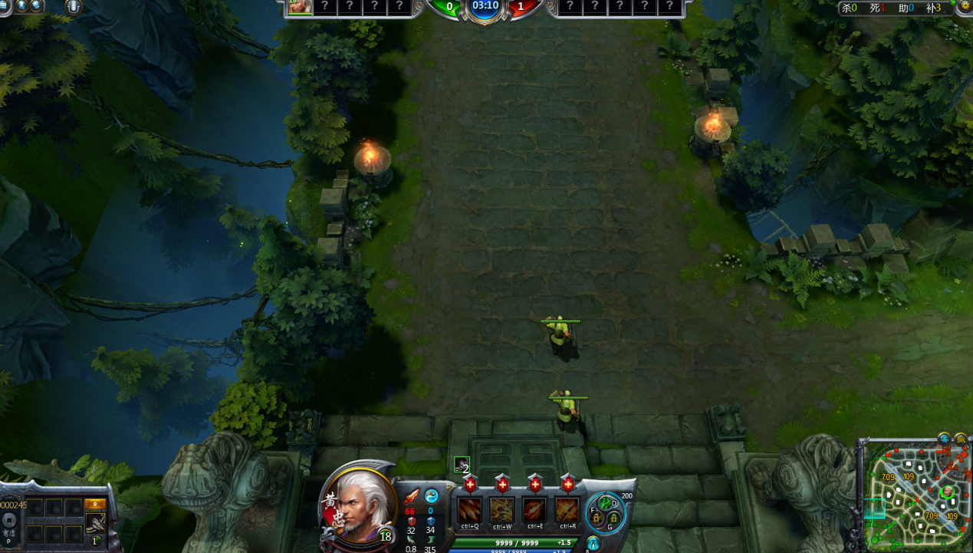

音乐名称  Music Name | 2.战斗前  2.Pre-battle
音乐类型  Music Type | 场景音乐  Scene Music
触发方式  Trigger Manner | one shot
最终提交时间  Final Submission Time | 2013/9/20
制作优先级  Production Priority | 低  Low
音乐时长  Music Duration | 2min30s
画面/背景描述  Picture/Background Description | 5V5玩法的大场景，魏蜀争霸。  Large-scale 5V5 scene, war affairs between the kingdoms Wei and Shu
相关美术资源  Related Art Resources | （见下图）  (As shown in the figure below)
音乐风格综述  Summary of Music Style | 氛围、神秘、不安、战斗前，总体来说属于该场景的氛围音乐，由于这首音乐被设计在5V5玩法开始时立即触发直到战争的号角响起。可以适当使用一定的合成器音色，以管弦为基础和打击乐互相配合营造出战斗前的感觉。  It is mysterious, uneasy and pre-battle, constituting an ambient music for the scene as a whole. This music is designed to be triggered immediately when the 5V5 game starts until the war horn sounds. An appropriate amount of synthesizer tone can be used to create a pre-battle atmosphere by setting the orchestra as the basis on which percussion music is added .
音乐风格详述  Description of Music Style | 可以使用合成器音色，以管弦为主、民乐可稍做点缀。建议使用人声合唱来做铺垫。 A synthesizer tone can be adopted, accompanied by some orchestra and folk music. Choir can serve as a background.
音乐风格详述  Description of Music Style | 不需要有太连贯的旋律线条。  A highly consistent melody line is not required.
曲式结构  Musical Structure | /
参考音乐  Reference | prehorn
备注
Remarks

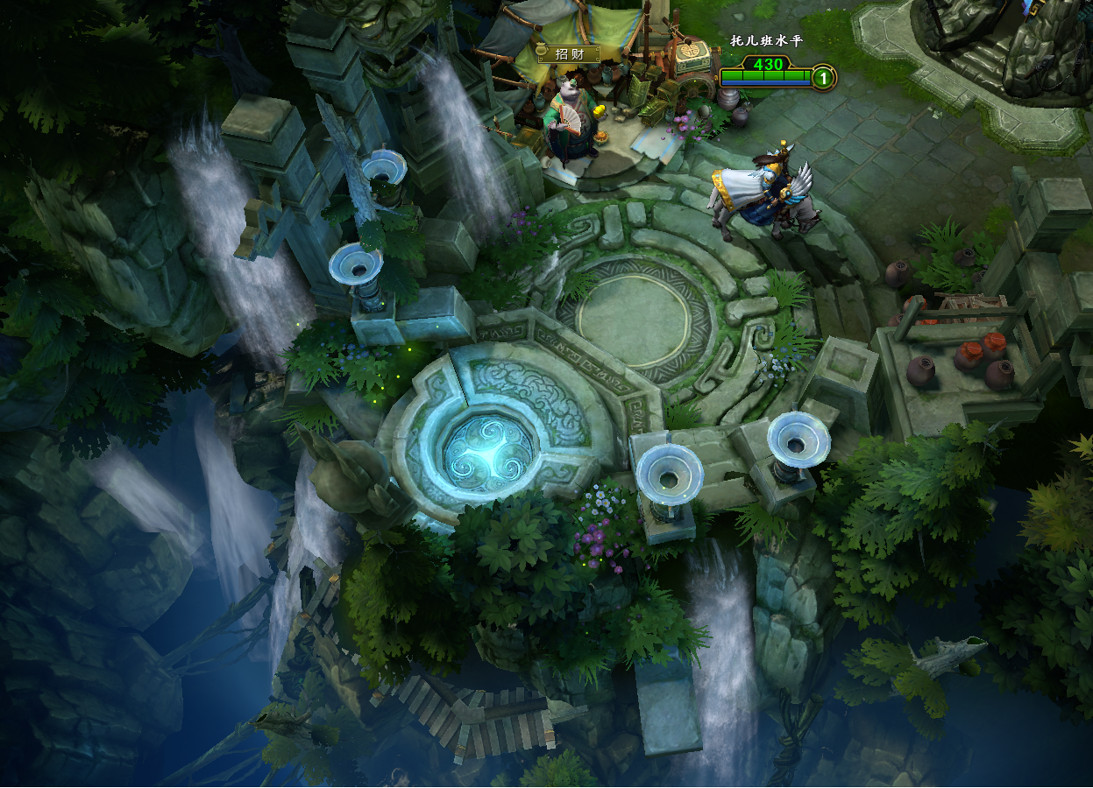

音乐名称  Music Name | 3.死亡音乐(death)  3.Death Music
音乐类型  Music Type | 场景音乐  Scene Music
触发方式  Trigger Manner | ont shot
最终提交时间  Final Submission Time | 2013/9/20
制作优先级  Production Priority | 中  Middle
音乐时长  Music Duration | 1min30s
画面/背景描述  Picture/Background Description | 5V5玩法的大场景，魏蜀争霸。  Large-scale 5V5 scene, war affairs between the kingdoms Wei and Shu
相关美术资源  Related Art Resources | 死亡状态的视频  Video of Death Status
音乐风格综述  Summary of Music Style | 5V5玩法里，玩家被击杀后在等待复活时播放的音乐。氛围音乐，具体可参考music_death和魔兽世界的死亡音乐。没有具体的旋律，可在管弦和合成器的基础上追加民乐和人声等，制作那种飘渺、庄严、悲凉的氛围。  It is the music that should be played after any player has been killed and waits for resurrection in the 5V5 mode. For the specific ambient music, refer to "music_death" and the death music of World of Warcraft. As no specific melody is present, folk music and voice can be added to orchestra and synthesizer, creating an ethereal, solemn and grieving atmosphere.
音乐风格详述  Description of Music Style | 可以使用合成器音色，以管弦为主、民乐可稍做点缀。建议使用人声合唱来做铺垫。  A synthesizer tone can be adopted, accompanied by some orchestra and folk music. Choir can serve as a background.
音乐风格详述  Description of Music Style | 具体曲式可以参考music_death  For specific musical forms, refer to music_death
曲式结构  Musical Structure | /
参考音乐  Reference | death（具体的曲式）  (Specific Musical Form )
备注  Remarks | 参考音乐皆为西方史诗配乐所以希望参考时要慎重，虽然产品方并没有要求过度强调民族风格，但是在写作时还是需要将其考虑进去。  All the music for reference is western epic music, which should be referenced to with caution. Although the product developer does not emphasize the folk style, it should be considered when composing.

音乐名称  Music Name | 4.复活stringer(respawn)  4.Resurrection
音乐类型  Music Type | 场景音乐  Scene Music
触发方式  Trigger Manner | ont shot
最终提交时间  Final Submission Time | 2013/9/20
制作优先级  Production Priority | 中  Middle
音乐时长  Music Duration | 9s
画面/背景描述  Picture/Background Description | 5V5玩法的大场景，魏蜀争霸。  Large-scale 5V5 scene, war affairs between the kingdoms Wei and Shu
相关美术资源  Related Art Resources | 复活状态的视频  Video of Resurrection Status
音乐风格综述  Summary of Music Style | 5V5玩法里，玩家被击杀后在复活时播放的短音乐，音乐设计上希望是有英雄重生的感觉。  It is the short music that should be played after any player has been killed and waits for resurrection in the 5V5 mode. The musical design should contribute to an ambience of rebirth of heros.
音乐风格详述  Description of Music Style | 可以使用合成器音色，管弦（使用铜管），人声（建议使用男低音区或者是能够体现爆发和力量的音色）等元素  A synthesizer tone, brass orchestra, voice (bass or other tones which can reflect an explosive power are recommended), etc are the options.
音乐风格详述  Description of Music Style | 具体曲式可以参考respawn  For specific musical forms, refer to respawn
曲式结构  Musical Structure | /
参考音乐  Reference | respawn（具体的曲式）  (Specific Musical Form)
备注  Remarks | 参考音乐皆为西方史诗配乐所以希望参考时要慎重，虽然产品方并没有要求过度强调民族风格，但是在写作时还是需要将其考虑进去。  All the music for reference is western epic music, which should be referenced to with caution. Although the product developer does not emphasize the folk style, it should be considered when composing.

音乐名称  Music Name | 5. 5V5战斗音乐  5. 5V5 Battle Music
音乐类型  Music Type | 战斗音乐  Battle Music
触发方式  Trigger Manner | one shot
最终提交时间  Final Submission Time | 2013/9/20
制作优先级  Production Priority | 高  High
音乐时长  Music Duration | 50s、45s （一共2首）  (2 songs in total)
画面/背景描述  Picture/Background Description | 5V5玩法的大场景，魏蜀争霸。  Large-scale 5V5 scene, war affairs between the kingdoms Wei and Shu
相关美术资源  Related Art Resources | 另附视频  Attached with video
音乐风格综述  Summary of Music Style | 史诗、雄壮、激烈、总体来说属于该场景的战斗音乐，玩家在丛林中探索时或者是在兵线与敌对玩家发生冲突和碰撞时触发播放的音乐，具体需要两条战斗音乐。  It is epic, magnificent and intense. In general, it pertains to the ambient music of this scene, that is, the music triggered when players explore into the jungle or when conflict and crash with other hostile players occurs on the batmen line. Two pieces of specific battle music are required.
音乐风格详述  Description of Music Style | 不需要太多的叙述铺垫部分，希望音乐一上来就能走到高潮并且能希望情绪是呈直线的走（不需要太多的情绪起伏），具体曲式、情绪等可见参考音乐。  Too a long narrative is not preferred for the foreshadowing. The music is expected to soar high from the beginning for a mood shooting up (without too much rise and fall). For specific musical forms and moods, see the reference part.
音乐风格详述  Description of Music Style | 管弦编配，以铜管为主、弦乐为辅可适当的使用人声（视效果而定），具体曲式可见参考音乐。  The orchestration is mainly based on brass, and supplemented with string. Voice can be used appropriately (depending on the effect). For specific musical forms, see the reference part.
音乐风格详述  Description of Music Style | 参考音乐皆为西方史诗配乐所以希望参考时要慎重，虽然产品方并没有要求过度强调民族风格，但是在写作时还是需要将其考虑进去。  All the music for reference is western epic music, which should be referenced to with caution. Although the product developer does not emphasize the folk style, it should be considered when composing.
曲式结构
Musical Structure
参考音乐  Reference | music_battle、music_battle_002
备注
Remarks

音乐名称  Music Name | 6. 5V5战斗音乐 结束句  6. End of 5V5 Battle Music （battle_end)
音乐类型  Music Type | 短音乐  Short Music
触发方式  Trigger Manner | one shot
最终提交时间  Final Submission Time | 2013/9/20
制作优先级  Production Priority | 高  High
音乐时长  Music Duration | 10s、10s （一共两首）  10s, 10s (A total of 2 songs)
画面/背景描述  Picture/Background Description | 5V5玩法的大场景，魏蜀争霸。  Large-scale 5V5 scene, war affairs between the kingdoms Wei and Shu
相关美术资源  Related Art Resources | 另附视频  Attached with video
音乐风格综述  Summary of Music Style | 需求五里战斗音乐的结束句 The end of the battle music in Requirement 5.
音乐风格详述  Description of Music Style | 结束句的开始部分最好能和战斗音乐的开头一样，要和战斗音乐部分的风格保持一致。  It is preferred that the opening of the end segment is consistent with that of the battle music, that is, to keep consistent in style with the battle music.
曲式结构  Musical Structure | 结构：战斗音乐---战斗结束句  Structure: battle music --- End of battle music
参考音乐  Reference | music_battle_end、music_battle_002_end
备注
Remarks

音乐名称  Music Name | 7. 过道音乐  7. Passageway Music（laning）
音乐类型  Music Type | 场景音乐  Scene Music
触发方式  Trigger Manner | loop
最终提交时间  Final Submission Time | 2013/9/20
制作优先级  Production Priority | 中  Middle
音乐时长  Music Duration | 2min30s
画面/背景描述  Picture Background Description | 5V5玩法的大场景，魏蜀争霸。  Large-scale 5V5 scene, war affairs between the kingdoms Wei and Shu
相关美术资源  Related Art Resources | （见下图）  (As shown in the figure below)
音乐风格综述  Summary of Music Style | 神秘、不安，游戏场景内有很多过道（在丛林中）丛林里有很多怪物或者是隐藏在暗处的敌对玩家。所以当玩家游走在丛林其实是处于一个相对危险的状态。在音乐设计上要求，突出危机和凝重的感觉。  It is mysterious and uneasy. In the game scene, as there are numerous monsters and hostile players hiding in the dark in the jungle, when walking in it, the players are actually in a relatively dangerous status. Thus, the music should be designed with a key stress on the sense of crisis and gravity.
音乐风格详述  Description of Music Style | 配器：以弦乐短弓为主、铜管和打击声部可用于强拍和重拍的点上，人声用与突出强拍和加强高潮旋律方面。  Orchestration: mainly based on the string bow, with brass and percussion on points of accented and strong beats, while voice can be used to highlight the strong beat and strengthen the climax melody.
曲式结构  Musical Structure | 需做分层处理，以layer01为主体（音乐中大部分的声部）layer02为辅助（举例：可以是人声和低音的弦乐短弓声部组成的）。  The musical structure is required to be layered, which uses layer01 as the main body (biggest part in concerted music) and layer02 as supplementary (for example: it may be composed of voice and string bow bass).
参考音乐  Reference | laning 可参考其配器  Refer to its orchestration
参考音乐  Reference | laning_choir声部  Refer to its Sound Part
备注  Remarks | 最终输出前，接口人会与外包沟通做细节上的调整，按声部来输出（约输出2~3首）并且需在样本上标明具体样本的BPM。  Before the final output, the linkman will communicate with the outsourcing agency for detailed adjustment, output by part (for 2-3 songs) and mark the BPM on each specific sample.
